|  |  |  |  |  |
| --- | --- | --- | --- | --- |
| Alarm#/code | Vendor | NE | Name | Severity |
| 2064 | Nokia | MGW/MSS | ROUTE SET UNAVAILABLE | Minor |
| 2070 | Nokia | MGW/MSS | LINK SET UNAVAILABLE | Critical |
| 2072 | Nokia | MSS | FAILURE IN SIGNALLING LINK ACTIVATION OR RESTORATION | Major |
| 2241 | Nokia | MSS | SCCP SUBSYSTEM PROHIBITED | Major |
| 2518 | Nokia | MGW/MSS | NO VALID FALLBACK COPY FOR DEFAULT PACKAGE | Major |
| 2673 | Nokia | MSS | MAXIMUM NUMBER OF EXECUTED DIGIT ANALYSIS EXCEEDED | Major |
| 2675 | Nokia | MSS | SS7 GROUP RESET MESSAGE RECEIVED TO UNUSED CIRCUITS/CIC | Minor |
| 2692 | Nokia | MSS/MGW | INCORRECT WORKING STATE | Critical |
| 2909 | Nokia | MGW | AIS RECEIVED | Minor |
| 2915 | Nokia | MGW | FAULT RATE MONITORING | Critical |
| 3156 | Nokia | MSS | ASSOCIATION ROUTING FAILURE | Critical |
| 3159 | Nokia | MGW/MSS | SCTP ASSOCIATION LOST | Minor |
| 3295 | Nokia | MGW/MSS | LICENCE CAPACITY EXCEEDED | Major |
| 3379 | Nokia | MGW/MSS | SCTP PATH FAILURE | Minor |
| 3474 | Nokia | MSS | VMGW OUT OF SERVICE | Critical |
| 3937 | Nokia | MGW/MSS | H.248 IP CONNECTION LOST | Critical |
| 33575171 | ZTE | MSS | Inter-Switch TDM Circuit on MGW controlled by MSC server link broken | Minor |
| 514 | ZTE | MGW | Trunk alarm indication signal | Major |
| 8417537 | ZTE | MGW/MSS | Association path broken | Major |
| 8402690 | ZTE | MGW/MSS | Association broken | Major |
| 8400384 | ZTE | MGW/MSS | M3UA office inaccessible | Critical |
| 8400129 | ZTE | MGW | MTP3 link unavailable | Critical |
| 8393987 | ZTE | MGW/MSS | Board offline | Critical |
| 8400128 | ZTE | MGW | MTP3 office inaccessible | Critical |
|  |  |  |  |  |
|  |  |  |  |  |

Instruction for below alarms:

2064- ROUTE SET UNAVAILABLE

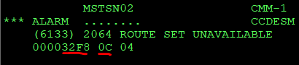

Point code = 32F8 (Hex), signaling network 0C = NA1 (if 08 = NA0);

To check: ZNRI:NA1,32F8;

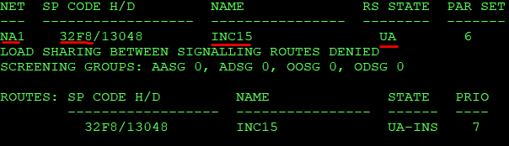

2070- LINK SET UNAVAILABLE

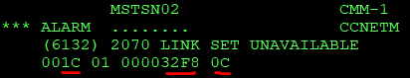

Link set number = 1C (Hex) ->28(Dec), Point code 32F8(Hex), signaling network = 0C -> NA1 (08 -> NA0)

To check: ZNSI:NA1,32F8;

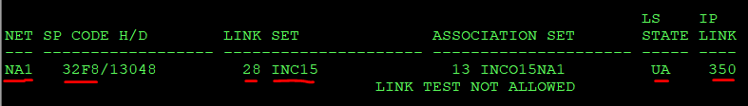

IP LINK = 350; IP Link can be checked: ZNEL:350;

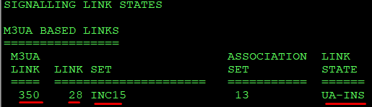

2072- FAILURE IN SIGNALLING LINK ACTIVATION OR RESTORATION



Number of signaling link =15E (Hex) -> 350 (Dec); ZNEL:350;

2241-SCCP SUBSYSTEM PROHIBITED

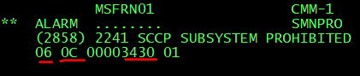

Subsystem number=06(Hex) -> (MAPH), list of other subsystems are like this:

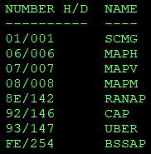

signaling network = 0C -> NA1 (08 -> NA0), point code = 3430(Hex);

To check SCCP subsystem -> ZNHI:NA1,3430;

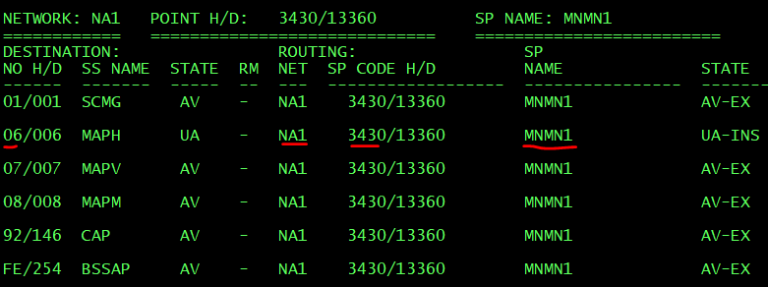

2518 - NO VALID FALLBACK COPY FOR DEFAULT PACKAGE

This alarm appears when backup copy for the default package fails. Please use this command to update the data of the latest backup file’s data:

ZWKS:MODE=DATA;

2673 - MAXIMUM NUMBER OF EXECUTED DIGIT ANALYSIS EXCEEDED

This alarm appears when call forwarding is involved during call setup. A number forwarded to B number, and at the same time B number forwarded to A. This case leads to loop and the end call setup fails. Please ignore this alarm.

2675 - SS7 GROUP RESET MESSAGE RECEIVED TO UNUSED CIRCUITS/CIC



This alarm appears when one of CIC or time slot is in abnormal state in CGR. MSS own point code = 3401(Hex), virtual circuit = 8266, time slot = 1;

Find out what CGR and which circuit: ZRCI:SEA=16:VCRCT=8266-1;

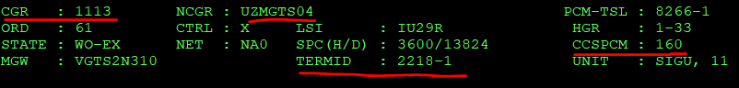

Form this we can see the state of circuit using this command: ZRCI:SEA=3:CGR=1113:PRINT=4 or ZRCI:SEA=3:NCGR=UZMGTS04:PRINT=4;



2692 - INCORRECT WORKING STATE

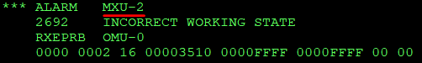

ZUSI:MXU,2;



2909 - AIS RECEIVED

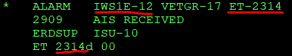

This alarm means that there is problem with transport, then transmission team need to be informed. You need to inform them which STM-1 and ETs, what direction. As example, it is IWS1E-12 and ET=2314. The direction can be defined through this MML:

ZRCI:SEA=4:CRCT=2314-1;



2915 - FAULT RATE MONITORING

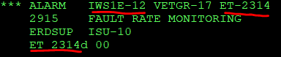

Like 2909 alarm, it also means that something happened with the TDM connection on particular STM-1 or E1. Please always inform also transmission team and let them know what IWS (IWS1E-12) and what ET (ET-2314) and define what direction, CGR it is: ZRCI:SEA=4:CRCT=2314-1;

3156 - ASSOCIATION ROUTING FAILURE



Usually this alarm concern M3UA (in our case it 03) or H.248 connection (if H.248 then the first value of supplementary information is 07). The alarm appears (second value of supplementary information is 02) when of the associations of association set is removed or missed (not exist). The fifth value of supplementary information shows what association set number it is: 48 (Hex) -> 72(Dec). ZOYI:NBR=72:A;

If you found that all association from 0 to N exist, please ignore this alarm.

3159 - SCTP ASSOCIATION LOST

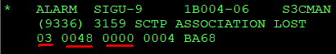 03 - > M3UA, association set = 48 (Hex) - > 72 (Dec), 3rd value of supplementary information means the association number, in our case it is 0: ZOYI:NBR=72:A;



3295 - LICENCE CAPACITY EXCEEDED

*** ALARM   CM-1

    3295    LICENCE CAPACITY EXCEEDED

    MLPPRB  CM-1

    1115d 43620d

Feature code = 1115d, ZW7I:FEA,FULL:FEA=1115;

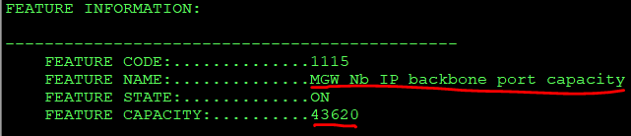

Maximum capacity is 43620. Current utilization can be checked by this MML:

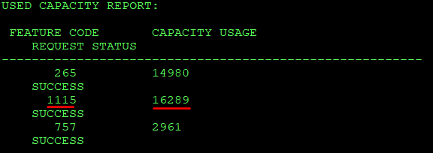 The alarm comes If the current capacity usage will reach to its maximum value (43620).

3379 - SCTP PATH FAILURE

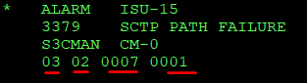 if first field of supplementary information is 03 – M3UA, if 07 it is for H.248; the second filed 02 means that secondary IPs are flapping, if 01 then primary IPs are flapping; third filed 0007 (Hex) is association set 0007(Hex) -> 0007 (Dec); fourth field is association index in association set;

ZOYI:NBR=7:A;

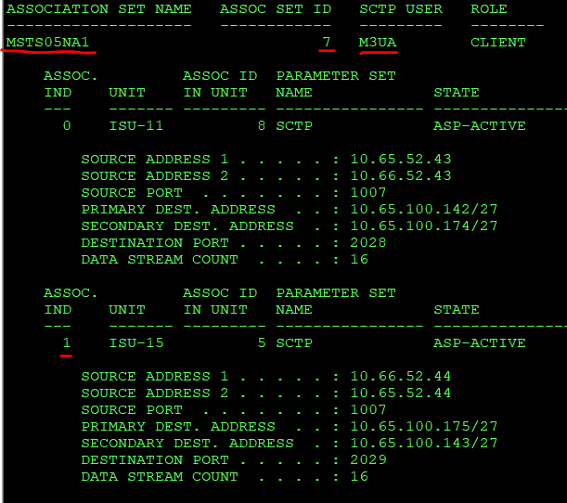

Example for SCTP Path failure when the first field of supplementary information is 07:

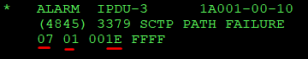 it is for H.248. In this case third filed is considered as VMGW ID (001E (Hex) -> 30 (Dec) and it is checked by this MML: ZJGI:MODE=0:MGWID=30;

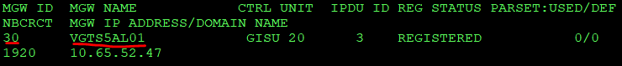

3474 - VMGW OUT OF SERVICE

|  |
| --- |
| *** ALARM CMM WGDPRB |
| (8112) 3474 VMGW OUT OF SERVICE |
| 0000001F |

VMGW ID is 1F (Hex) -> 31 (Dec): ZJGI:MODE=0:MGWID=31;

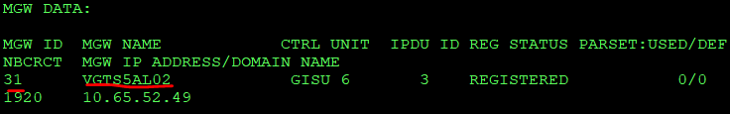

3937 - H.248 IP CONNECTION LOST

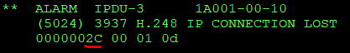   VMGW ID is 2C (Hex) -> 44 (Dec): ZJGI:MODE=0:MGWID=44;

33575171 - Inter-Switch TDM Circuit on MGW controlled by MSC server link broken

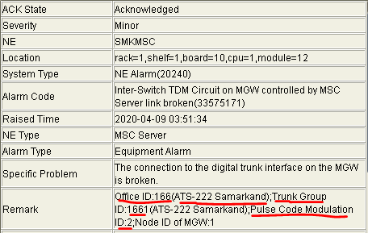

SHOW TG:TG=1661;



Find out Pulse Code Modulation(PCM) ID: SHOW SPCM:TG=1661;



This alarm appears when one of PCM is down, in our case it is PCM ID: 2

514 - Trunk alarm indication signal

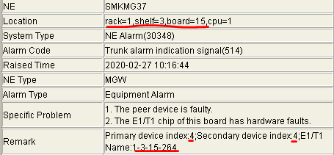 The alarm means that one of E1 of STM-1 is in abnormal state. In our case, STM-1 board is located on Rack 1, Shelf 3, Slot 15. Remark shows which port of STM-1 has problem (it Primary device index = 4), which E1 (Secondary device index = 4), and what sub unit =264;

Using above data we can use this command:

SHOW E1T1:UNIT=1531,MASDEVICENO=4,SUBDEVICENO=4;



When you put UNIT, you have to write STM-1 position in opposite order, it means first slot number, then sheld and at the end put rack (like this slot|shelf|rack = 1531);

Then you can check the state of above E1 using the above sub unit (264):

SHOW SUNITSTAT:UNIT=1531,SUNIT=264;



8417537 - Association path broken

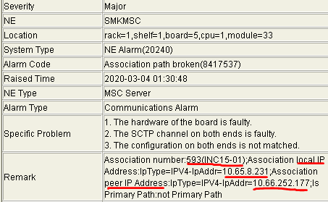

SHOW SCTP:ID=593;



The alarm means there is flapping of local and peer IPs, in our case local IP flapped from 10.65.8.230 to 10.65.8.231 and peer IP flapped from 10.65.252.177 to 10.66.252.177

8402690 - Association broken

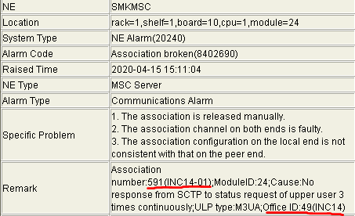

Check how many SCTP connection Office ID:49 (INC14) has:

SHOW SCTP:OFCID=49;



Status of SCTP can be checked by this command (in our case, the alarm came for SCTP ID: 591)

SHOW SCTPSTAT:ID=591;

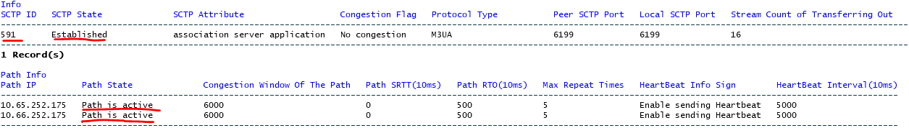

When alarm appears the state of SCTP has status “Closed” and path states “Path is not confirmed”

8400384 - M3UA office inaccessible

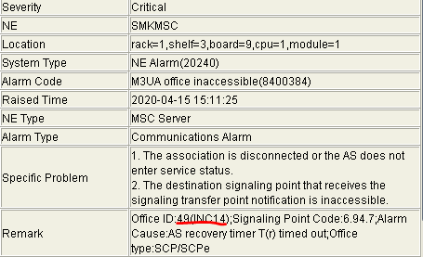

The alarm appears when all links of particular Office (in our case it 49) are in abnormal status.

To see the status of all offices: SHOW ALLOFFICESTAT and go to Operation Record

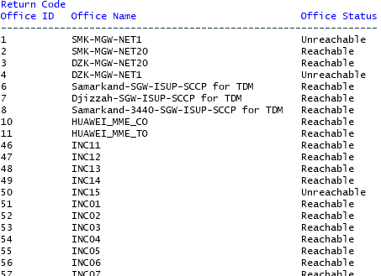

8400129 - MTP3 link unavailable

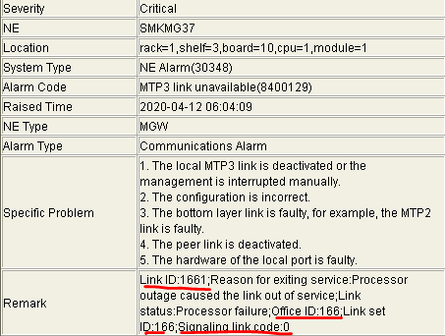

SHOW TDMN7LNK:ID=1661;



8393987 - Board offline

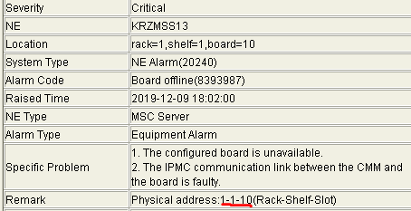

Usually this alarm appears when particular board is faulty. Use this command to check what board it is:

SHOW BOARDNAME:RACK=1,SHELF=1,SLOT=10;



Use this command to check the status of the board:

SHOW BOARDSTATE:RACK=1,SHELF=1,SLOT=10;

8400128 - MTP3 office inaccessible

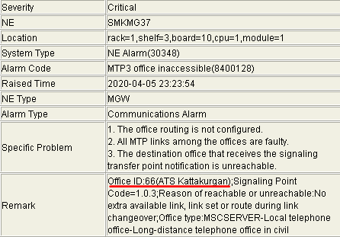

Same as alarm 8400384 it appears when all links of particular Office (in our case it is 66) are in abnormal status.

Use SHOW ALLOFFICESTAT command to check status of all offices.